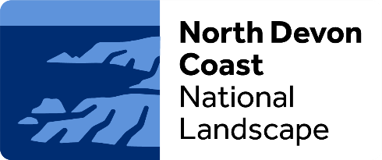

Partnership

Community Representative Application Form
Name
Email address
Telephone
Address
My connection to the North Devon Coast is (max 300 words, expand box or continue on a separate sheet if necessary):

I would like to become a Community Representative on the North Devon Coast National Landscape Partnership because (max 300 words, expand box or continue on a separate sheet if necessary):

My vision for the future of the National Landscapes is (max 300 words, expand box or continue on a separate sheet if necessary):

My formal involvement or experience with any organisations, businesses or communities in Northern Devon is (max 300 words, expand box or continue on a separate sheet if necessary):
Please return the completed form to AONB@Devon.Gov.UK

